**Preparation and Maintenance of ZOHO Books for Bright Ideas Consulting**

**Project Team members: Raihana Begam.A, Roja Jasmine.S, Ruthra Priya.S, Safriyya Thasneem.M**

**1. INTRODUCTION**

**1.1 Overview:**

This project is deal bright ideas counsulting ZOHO Books to effectively manage their financial processes, maintain accurate records, and make informed financial decisions. This integration enhances their overall business efficiency and contributes to their success in the interior design industry.

**1.2 Purpose:**

By maintenance of accounts in ZOHO Books, We have created the Items, Vendors creation, Preparation of Purchase Order, Purchase Invoice, Customer creation, Preparation of Sales order, Sales Invoice, creation of bank account, creation of new accounts, recording journal entries, recording expenses, recording bank receipts and payments and viewing of financial reports like Profit & Loss account, Balance sheet, GST Reports, Journal report, Account receivable summary report, Account payable summary report, etc.,

**2. Problem Definition & Design Thinking**

2.1 Empathy Map

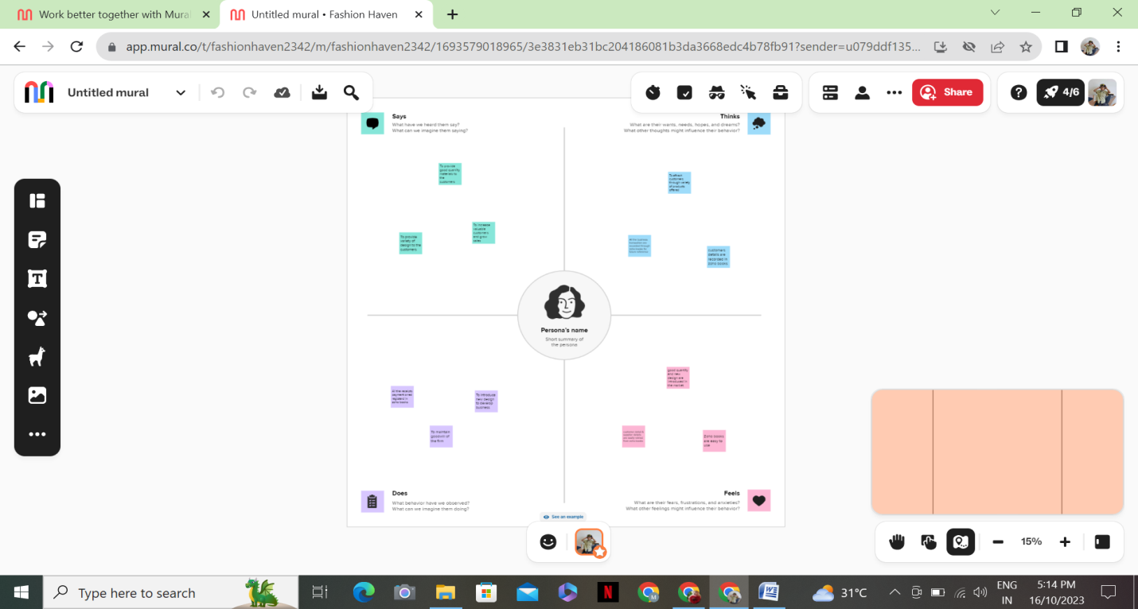

2.2 Ideation & Brainstorming Map

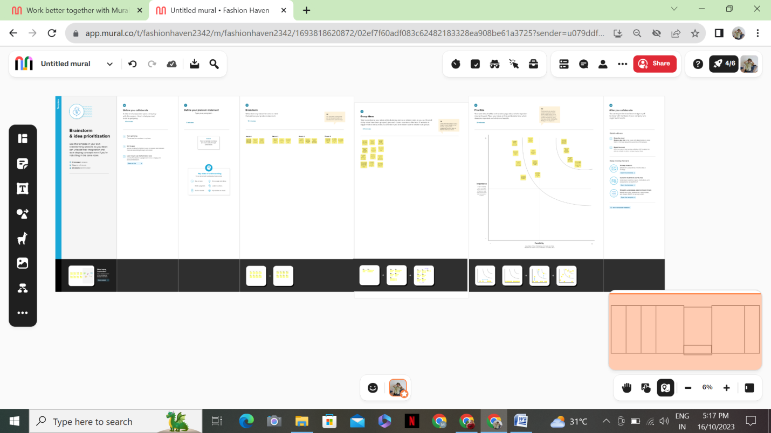

**3. RESULT:**

To Generate the Financial Reports:

1. Profit and Loss Account:

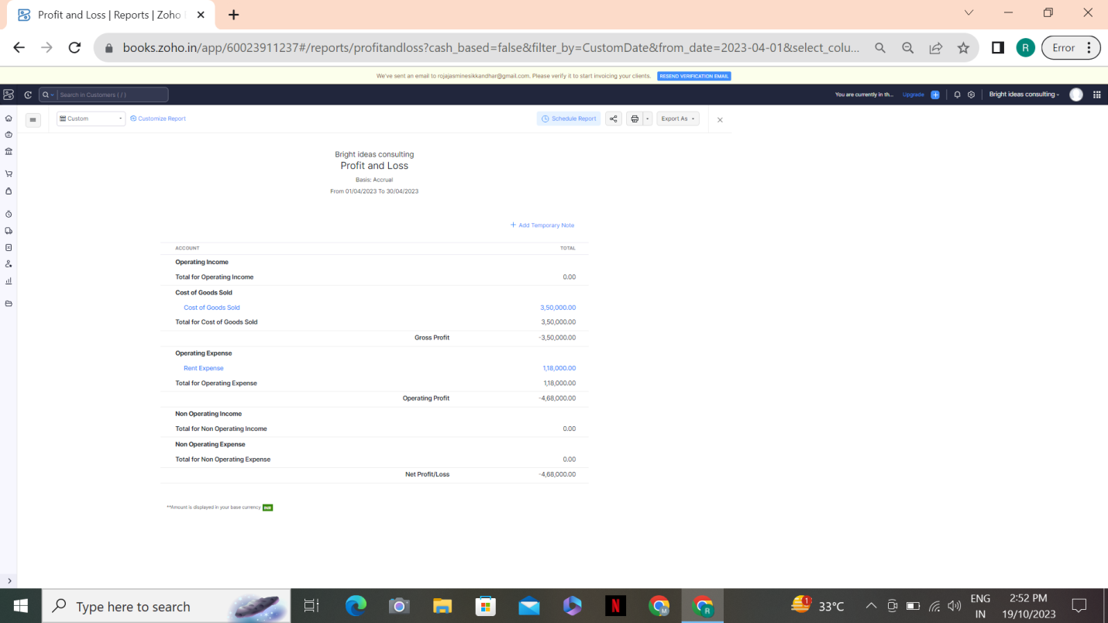

1. Balance Sheet

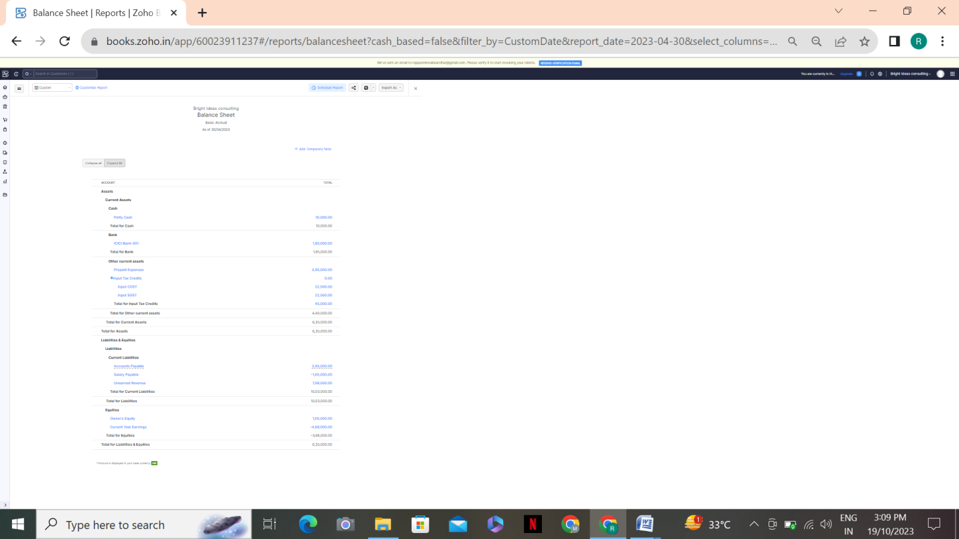

1. GST Reports

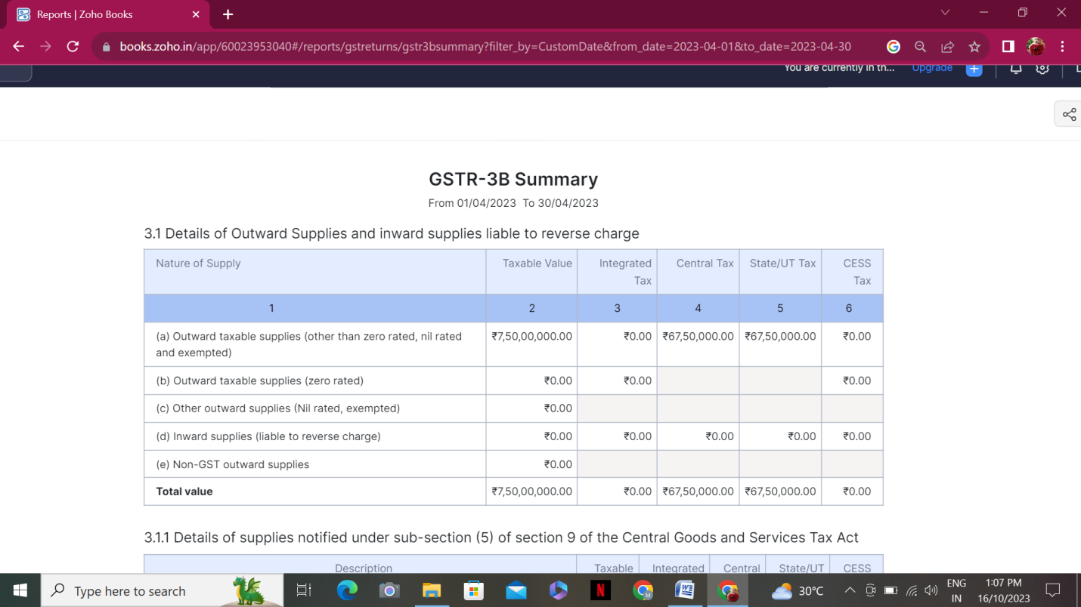

1. Journal Report

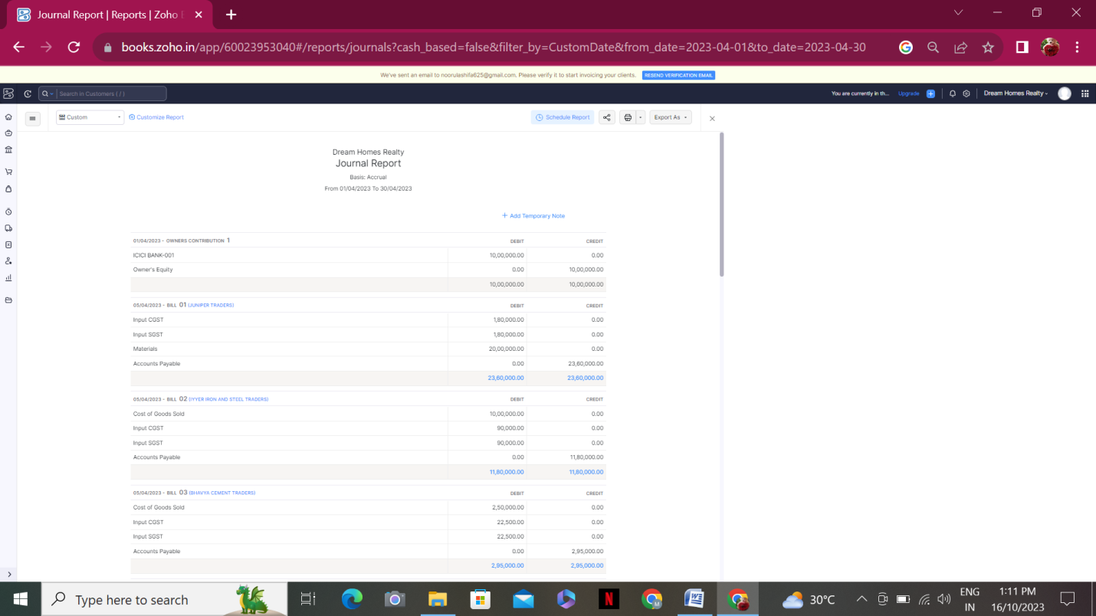

1. Accounts Receivable Summary

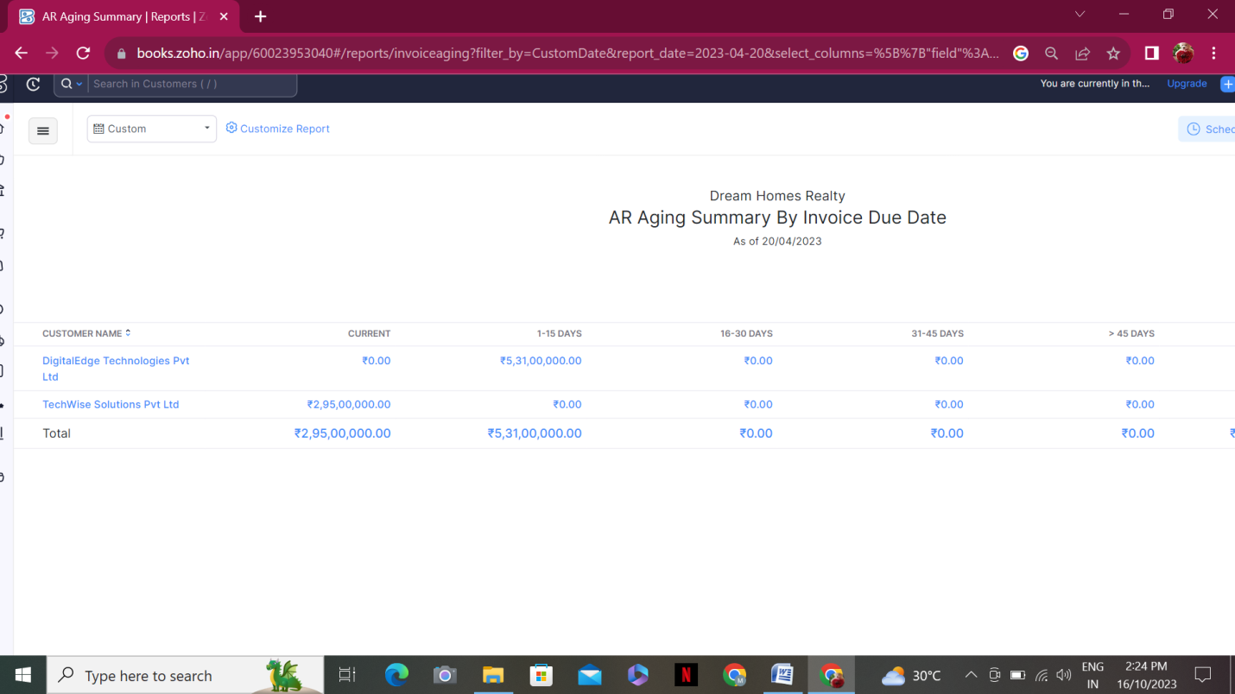

6. Accounts Payable Summary

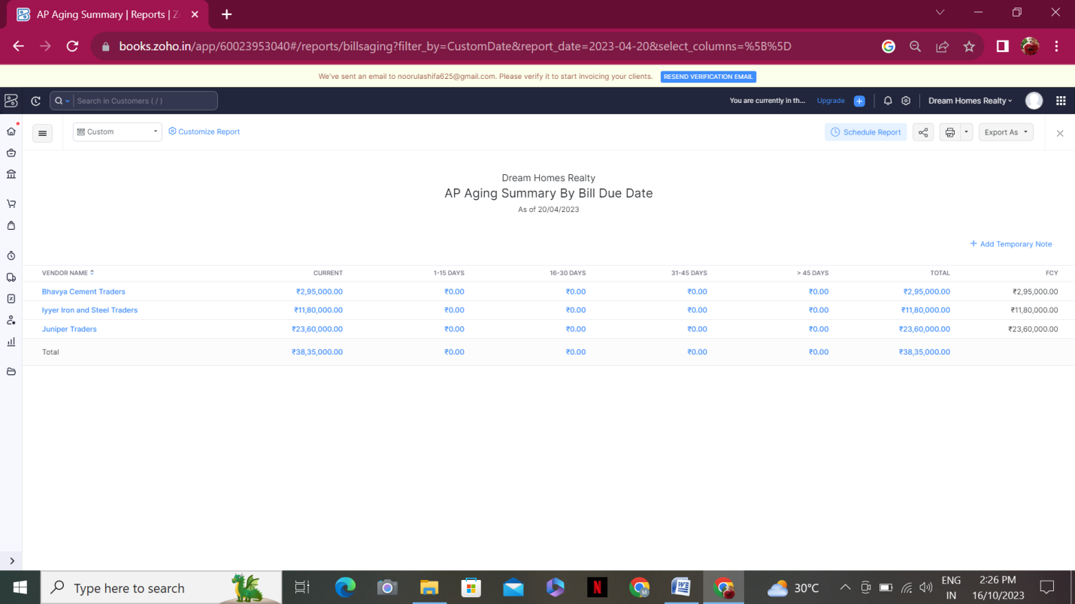

**4. ADVANTAGES & DISADVANTAGES**

List of advantages:

* ZOHO books is cloud based software, so we access the software in any location.
* Creating of Organistion is very easy and user friendly.
* Appearance of software model is very easy to understanding.
* Creation of items, vendors, customers are user friendly while compare with software
* Preparation of purchase order and conversation to purchase Invoice made in a single step.
* Preparation of Sales order and conversation to Sale Invoice made in a single step.
* Default accounting step up is very useful and time saving.
* GST procedure is very easy to enter.
* Getting financial report and tax report in single step.

List of disadvantages:

* ZOHO books is cloud based software, which need internet and other technical facility.
* In absence of internet facility, the working in ZOHO books is very difficult.
* There is no secure in data of the organization.

**5. APPLICATIONS:**

The ZOHO Books is good software in all type of organization and we get better results instantly. We collect the following data and entered in ZOHO Books in various modules like item creation, Vendor creation, customer creation, preparation of Purchase order, Purchase Invoice, sales order, sale Invoice, Making payment to vendors and Expenses, Received amount from Customers.

**Item creation:**

1.Management Consulting

2.Financial Consulting

3.Human Resources (HR) Consulting

4.Legal consulting

**Vendor creation:**

1. Randstad (GST registered)

2. Amazon Web Services (GST registered)

3. Raj Kamal External Consulting(Non GST )

**Customer creation:**

1. TechWise Solutions Pvt Ltd (GST Registered).
2. DigitalEdge Technologies Pvt Ltd(GST Registered ).
3. SmartTech Innovations (Non GST)

**Preparation of Purchase order ,Purchase Creation:**

1. 10-04-2023 Cloud database from amazon web service-RS.50000/-pm GST @18%
2. 10-04-2023 Consultancy services from raj kamal external consulting-RS.100000/-pm

**Preparation of sales order, sale Invoice:**

1. 10/04/2023 Techwise solutions PVT Ltd – 100 HRS Of financial consultation - paid through bank on 25/04/2023

**Making payment to vendors and Expenses:**

1.Employee salaries of total Rs.25,00,000/- paid through bank on 30th April 2023.

2.Office Rent Rs.2,00,000/- excluding GST @ 18% Total Invoice Value Rs.2,36,000/- paid in Bank on 30-04-2023

3.Labour Cost Rs.15,00,000/- paid in Bank on 20-04-2023

4. Other Miscellaneous Expenses Rs.5,000/- paid in cash on 30-04-2023

5. 25-04-2023 Paid to rand stand technologies 2,36,000

6. 25-04-2023 Paid to amazon web services 59000

7. 25-04-2023 Paid to rajkamal external consulting 100000

**Received amount from customers:**

1.12-04-2023 Amount received from techwise solutions 118000

2.20 -04-2023 Amount received from smarttech innovations 236000

3.25-04-2023 Amount received from digital edge technologies 354000

**6. CONCLUSION:**

In maintain of dream homes realty accounts in Zoho books is very smart in all the aspects of entries. The basic accounting concept is enough for the operating person(Accountant/Data entry operator). This software is applicable for all types of organization. The entry models of software are easily understood and interest to work. Whatever reports we need, it’s already default in the report models. Totally it’s a good and very useful to the entire entrepreneur with low cost for operating financial department.

**7. FUTURE SCOPE:**

The idea for the founders of ZOHO Books is amazing and very clever. This is a great milestone in the field of accounts maintenance. They offer various plane as per the requirement of the proprietors. It’s a good gift to all the entrepreneurs.